Distance Learning
with Mrs. Day

May 11th-15th

Required Materials
We’re finishing our first read of Animal Farm this week!
You can read the whole book here: http://gutenberg.net.au/ebooks01/0100011h.html
And you can listen to the whole book here:
https://www.leonschools.net/Page/46276
Notes for This Week
Be patient with yourselves.
I’ve heard from a lot of people (both parents and students) who are BURNED OUT on distance learning. I get it. Here are my suggestions: plan a FaceTime/Zoom call and work with classmates, ask teachers for live sessions to help you, or try a new routine (like math in the morning, language arts after dark). We’ve got this week and next as our final push (the one after will be wrapping up), so keep your head down and let’s finish strong!
Remember that I’m live in Teams every day for my office hours from 1:00-3:00.
That’s a great chance to ask a question (and get a quick answer), or just stop by and say hi to your old pal Mrs. Day!
Week 7 Overview Checklist
- Read Chapters 9 and 10 of Animal Farm
- Mini-Research Project - Themes
- Allegory Study
- Covid Crisis Journal #6
- Family Game Time – Puzzles
Parent Assignment for Week 7
- Take it easy on yourself! We’re almost at the (school year) finish line!
- Task: Read Chapters 9 and 10 of Animal Farm
*I’ll be reading Chapter 9 with you on Tuesday (5/11) and Chapter 10 on Thursday (5/14) in Teams. Those “classes” are completely optional, as usual.

- Task: Mini-Research Project - Themes

For this assignment, you will choose one of the themes explored in Animal Farm to research and explain. You may choose Tyranny, Personality Cults, Propaganda, Revolution, or Class Warfare. If you’ve noticed another theme and would like to research it, great! Please run your idea by Mrs. Day first.
Use reliable sources to learn about your topic. Report your findings thoroughly and completely, imagining that you are preparing for an informative speech or essay. You’re not (), but that may help guide your research. This is an assessment grade, so please reach out to Mrs. Day if you would like guidance.
​
Your Chosen Theme: ​_____________________________________________
What does this term mean? ​ _________________________________________________
__________________________________________________________________________________________
___________________________________________________________________________________________
Where, in history, can you find examples of this idea/phenomenon? _______________________________________
________________________________________________________
__________________________________________________________________________________________________________________________________________________
What modern/current examples are there of this idea? ___
________________________________________________________
__________________________________________________________________________________________________________________________________________________
Where is this concept found in Animal Farm? ____________
________________________________________________________
__________________________________________________________________________________________________________________________________________________
What sources did you use to find your information? _____
________________________________________________________
________________________________________________________
How did you decide that these sources were reliable and accurate? ______________________________________________
__________________________________________________________________________________________________________________________________________________

- Task: Covid Crisis Journal #6
Remember, you don’t have to answer my prompt. If you wish, you may simply write a paragraph (five-seven sentences) about what you’re thinking, doing, reading, feeling, or experiencing (etc.) during this moment in history.

Prompt #6 – It’s been several weeks since I’ve asked for this particular reflection; I’d like to get a window into your daily routine. Write everything you do in a day, from waking up to going to sleep. You can do it as a list, or in paragraph form. I think that someday it will be interesting to you to see what your life was like in quarantine.
________________________________________________________________________________________________________________________________________________________________________________________________________________________________
_______________________________________________________________________________________________________________________________________________________________________________________________________________________________________________________________________________________
- Task: Allegory Study

To complete this task, watch Mrs. Day’s YouTube video called “Animal Farm Allegory” (on my YouTube channel). Use the video to fill the blanks below. The idea is that you make guesses as you go, and you can always change them.
Ex. Lenin = __Napoleon__ Molotov = _____________________
__________________ = Boxer _____________________ = Moses
Animalism = _______________ The Dogs = _________________
Snowball’s expulsion = _________________________________

What is one random/interesting/fun fact you learned from this video? ____________________________________________
________________________________________________________

Now that you know the “real” meaning of Animal Farm, does it add to your interest/understanding of the novel? Explain. _______________________________________________
________________________________________________________
________________________________________________________
- Task: Family Game Time – Puzzles
How many of the puzzles below can you figure out? You’re welcome to collaborate with your friends and family, in addition to our school family members!
1. Which shape fits? ______
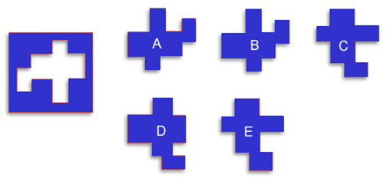
2. How many blocks are in the picture? _________
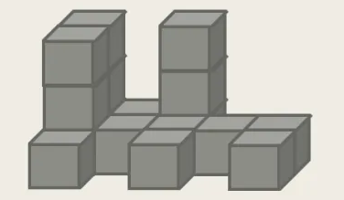
3. Can you solve the Rhebus puzzles?
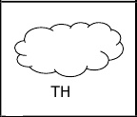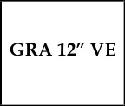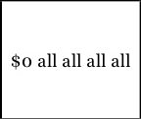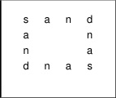
___________________ ___________________ ___________________ ___________________
4. What do these four things have in common? _____________________________

A shark’s bones

Alfred Hitchcock’s Oscars

Locks on the love bridge (now)
Paintings signed by Leonardo
I’ll randomly select five people who get all four correct, and mail them a prize!

